 | Document Name | Storage Migration using NPIV
 | Document Number | MYL-UNX-SOP-SMNPIV- 001
 | Type of document | Standard Operation Procedure
 | Revision No: | 1.0

Table of Contents
1. PURPOSE 2
2. SCOPE 2
3. PROCEDURE: 2
4. DEFINITIONS: 2
5. VERSION HISTORY 12

PURPOSE
  - This document defines the NIPV configuration on individual LPARs and Storage Migration procedures.

SCOPE
  - As part of Storage Migration, we are proposing NPIV configuration to reduce the VIO IO handle Issues.
  - We need to create NPIV adapter in HMC on LPAR profile.
  - We should map those adapters to VIO Adapter, then configure it on LPAR.
  - Storage team will map the PowerMax LUNs to NPIV adapter, UNIX Team will use this LUNs for storage migration

PROCEDURE:

3.1. NPIV Configuration

We should login into the HMC using our MID and password

Expand the Server Management, the Navigate to Servers.

Expand the Servers, and click on the appropriate Physical Frames

Select the LPAR, then click the arrow button. 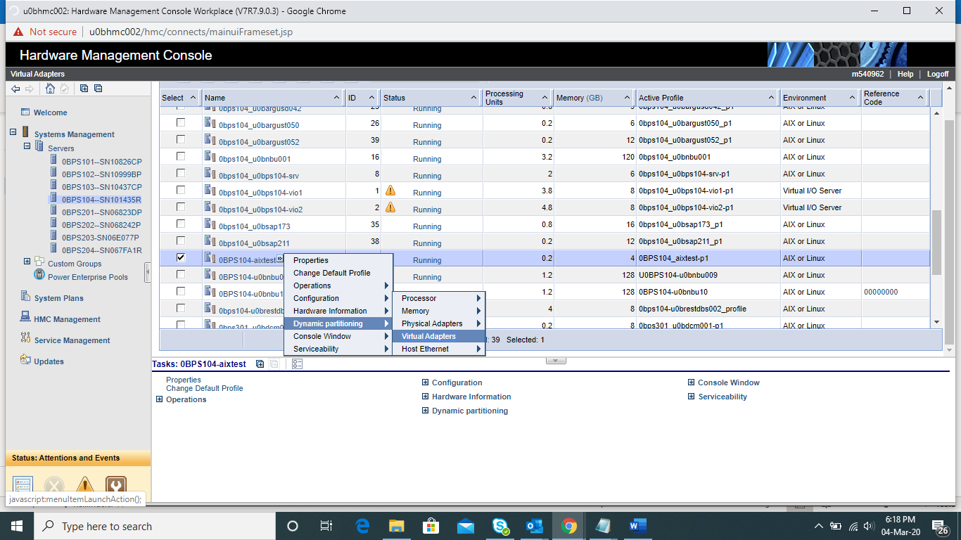

Navigate to Dynamic partitioning, then click on virtual adapter

Now virtual adapter Popup Screen will open.

Click Action Button, Navigate to Create virtual adapter, then click the fiber channel adapter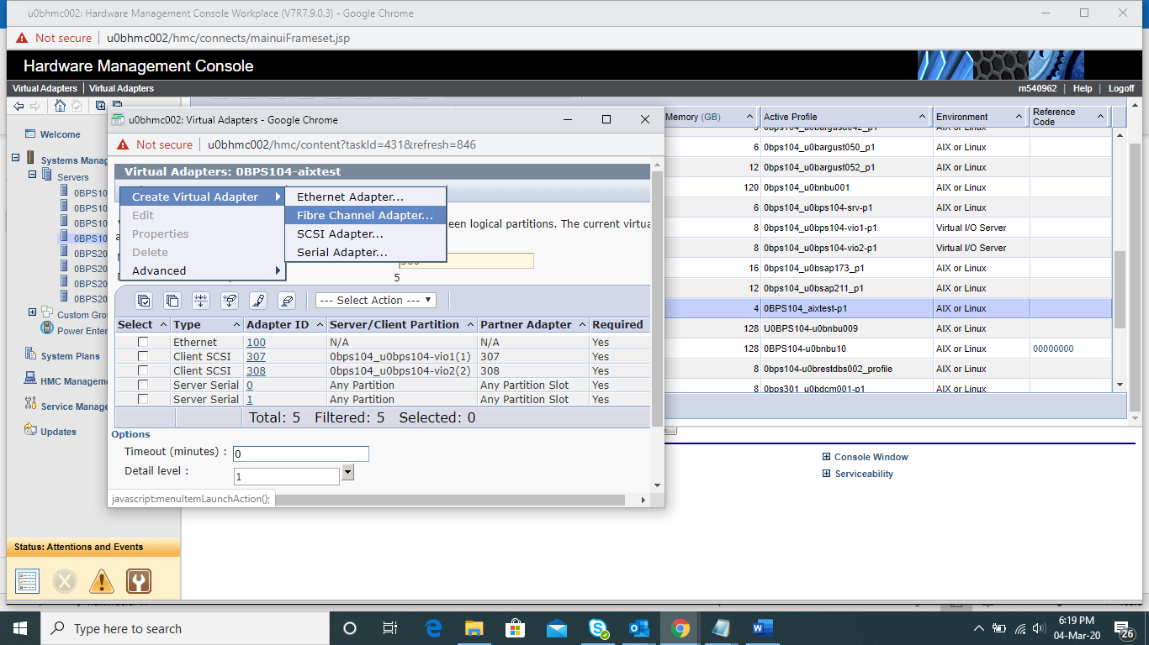

Create Virtual Adapter Popup will open, there we should define the Adapter ID

Server Partition filed, we should select the VIO, the we need to define the VIO adapter ID

We should use the below numeric values for virtual adapters. if lpar ID 10 then adaptor id will be 106 at client virtual adapter, And same ID should be create in VIO as well.

Standards for Adapters
Ethernet Adapter | vscsi Adapter | FC Adapter
0,1 | 2,3,4,5 | 6,7

Then click OK to finish the configuration. 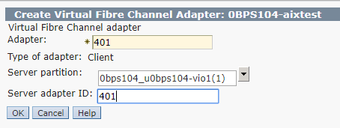

Now select the VIO, click on Arrow button

Navigate to Dynamic Adapter, then click on virtual adapter 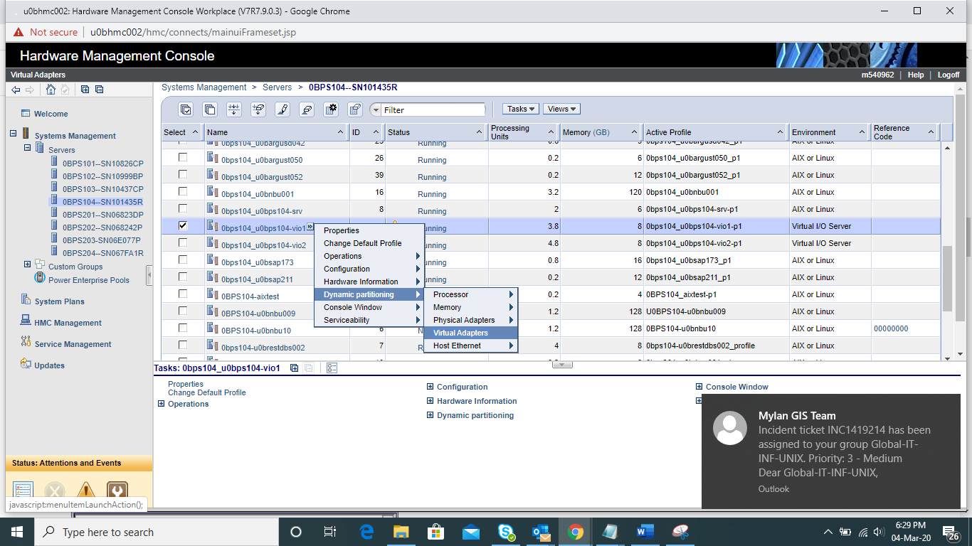

Now virtual adapter Popup Screen will open.

Click Action Button, Navigate to Create virtual adapter, then click the fiber channel adapter 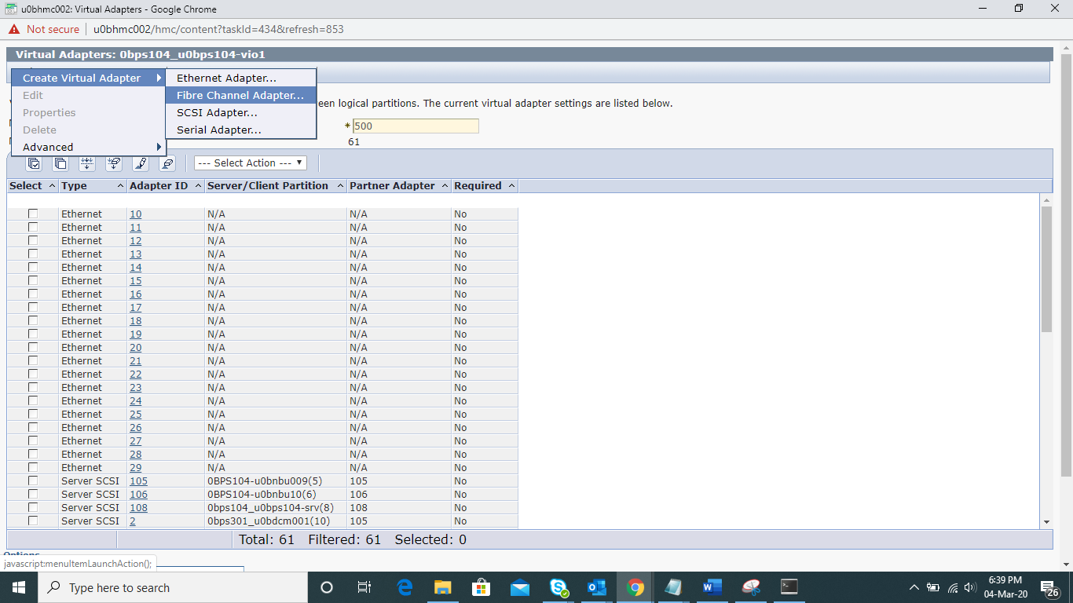

Create Virtual Adapter Popup will open, there we should define the Adapter ID

Client Partition filed, we should select the Appropriate LPAR, the we need to give LPAR adapter ID, which we gave in the step – 8.

Then click OK to finish the configuration. 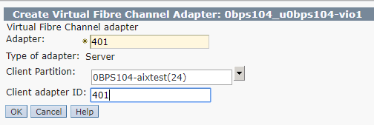

Note: we have completed the Adapter creation on VIO1 and LPAR, for reduntancy purpose, we need to create it on VIO2 so repeat the step 4 to step14

Validate the WWPN details LPAR virtual adapter properties 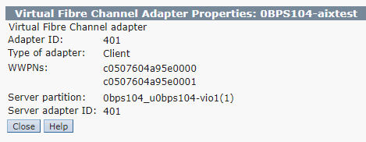 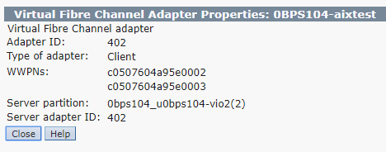

Note: If any error happened on rmc connection, use below mentioned command for start the service.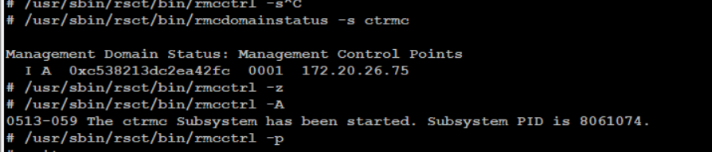

We should map the adapters in VIO level, hence we need to login into the VIO’s

To discover the device on VIO, run “cfgdev” command. 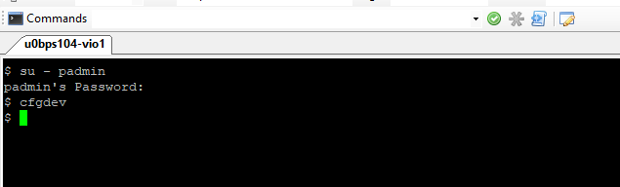 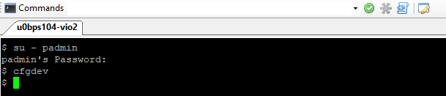

Then check the NPIV Adapter details in VIOs

Using lsnports command check the active physical adapter.

Then map the virtual adapter to the physical adapter 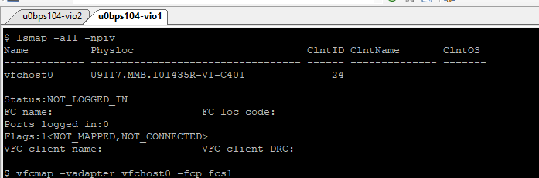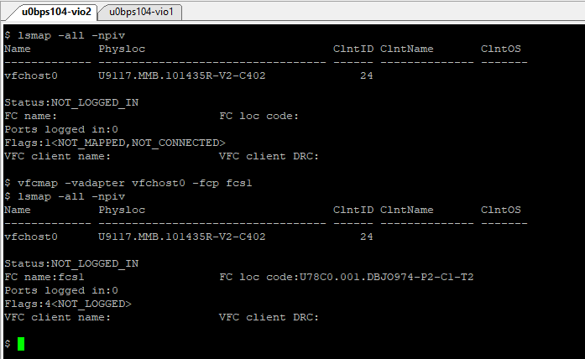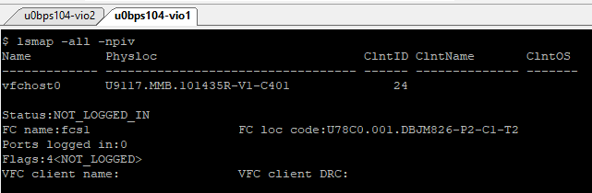

Now login to the LPAR, then switch to root “sudo su –“

Discover the devices, run the cfgmgr command

# uname -n

u0bps201-srv

# lsdev -Cc adapter

ent0 Available Virtual I/O Ethernet Adapter (l-lan)

vsa0 Available LPAR Virtual Serial Adapter

vscsi0 Available Virtual SCSI Client Adapter

vscsi1 Available Virtual SCSI Client Adapter

# cfgmgr

# lsdev -Cc adapter

ent0 Available Virtual I/O Ethernet Adapter (l-lan)

fcs0 Available 22-T1 Virtual Fibre Channel Client Adapter

vsa0 Available LPAR Virtual Serial Adapter

vscsi0 Available Virtual SCSI Client Adapter

vscsi1 Available Virtual SCSI Client Adapter

#

3.2 Storage Migration

Provide the WWPN to storage team for allocate the LUN, they will give you the LUNs from PowerMax Storage.

Before scan the LUN from LPAR client, we should install the EMC ODM package.

For AIX 5.3 and 6.1, we need to use “EMC.AIX.5.3.0.8.tar” package and Aix 7.1 we nned to use “EMC.AIX.6.0.0.0.tar”

Extract the file in /tmp directory.

Using “smit installp” start the package installation 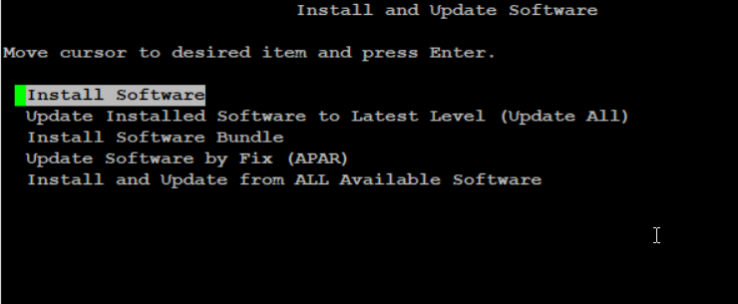 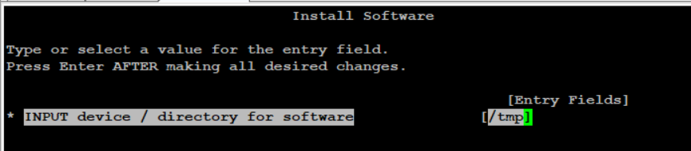

Select the below mentioned specific two packages for ODM installtion.

Once Installtion completed, Storage team will provide the LUN, scan it from LPAR level. Using cfgmgr command.

Check the newly added disk in “lspv | grep -I none” and check the created time on “ls -lrt /dev/hdisk*”

Use the attr_disk.ksh script for change the disk attributes. “/usr/admin/aix/scripts/pmax_mig/ attr_disk.ksh” It will modify the below mentioned attributes “algorithm round_robin, queue_depth 32, reserve_policy no_reserve, max_transfer 0x100000”

Add the PVID on newly added disks.

root@u0bps201-srv /> chdev -l hdisk1 -a pv=yes

hdisk1 changed

root@u0bps201-srv /> lspv

hdisk0 00f6823d11048fa5 rootvg active

hdisk1 00f6823ded175094 None

We should add the PV in to Existing VG via extendvg, then check the PP size in pv and vg level. Then we have to migrate the data from old disk to new disk by start the mirroring. “command is mirrorvg, Once Mirroring is completed. Kindly validate the lv state and pv occupation size of new disk. If everything migrated, then we need to unmirror the volume from the VG, the remove the disk from the vg using reduce vg.

root@u0bps201-srv /> extendvg rootvg hdisk1

root@u0bps201-srv /> mirrorvg -S rootvg hdisk1

0516-1259 mirrorvg: None of the available disks support booting on this

specific system or the boot logical volume already exists on

the specified disk.

If these are new bootable disks and you

have not rebooted since configuring them. You may try

exporting LVM_HOTSWAP_BOOTDISK=1 and run this command again

to override this condition.

0516-1200 mirrorvg: Failed to mirror the volume group.

root@u0bps201-srv /> mirrorvg -S rootvg hdisk1

0516-1259 mirrorvg: None of the available disks support booting on this

specific system or the boot logical volume already exists on

the specified disk.

If these are new bootable disks and you

have not rebooted since configuring them. You may try

exporting LVM_HOTSWAP_BOOTDISK=1 and run this command again

to override this condition.

0516-1200 mirrorvg: Failed to mirror the volume group.

root@u0bps201-srv /> export LVM_HOTSWAP_BOOTDISK=1

root@u0bps201-srv /> mirrorvg -S rootvg hdisk1

0516-1804 chvg: The quorum change takes effect immediately.

0516-1126 mirrorvg: rootvg successfully mirrored, user should perform

bosboot of system to initialize boot records. Then, user must modify

bootlist to include: hdisk0 hdisk1.

root@u0bps201-srv /> lspv hdisk1

PHYSICAL VOLUME: hdisk1 VOLUME GROUP: rootvg

PV IDENTIFIER: 00f6823ded175094 VG IDENTIFIER 00f6823d00004c000000015f15c94bdb

PV STATE: active

STALE PARTITIONS: 190 ALLOCATABLE: yes

PP SIZE: 128 megabyte(s) LOGICAL VOLUMES: 11

TOTAL PPs: 479 (61312 megabytes) VG DESCRIPTORS: 1

FREE PPs: 283 (36224 megabytes) HOT SPARE: no

USED PPs: 196 (25088 megabytes) MAX REQUEST: 512 kilobytes

FREE DISTRIBUTION: 95..03..00..89..96

USED DISTRIBUTION: 01..93..95..07..00

MIRROR POOL: None

root@u0bps201-srv /> lsvg rootvg

VOLUME GROUP: rootvg VG IDENTIFIER: 00f6823d00004c000000015f15c94bdb

VG STATE: active PP SIZE: 128 megabyte(s)

VG PERMISSION: read/write TOTAL PPs: 863 (110464 megabytes)

MAX LVs: 256 FREE PPs: 471 (60288 megabytes)

LVs: 11 USED PPs: 392 (50176 megabytes)

OPEN LVs: 10 QUORUM: 1 (Disabled)

TOTAL PVs: 2 VG DESCRIPTORS: 3

STALE PVs: 1 STALE PPs: 86

ACTIVE PVs: 2 AUTO ON: no

MAX PPs per VG: 32512

MAX PPs per PV: 1016 MAX PVs: 32

LTG size (Dynamic): 512 kilobyte(s) AUTO SYNC: no

HOT SPARE: no BB POLICY: relocatable

PV RESTRICTION: none INFINITE RETRY: no

DISK BLOCK SIZE: 512 CRITICAL VG: no

FS SYNC OPTION: no

Install the boot Image on the new disk. Then remove the old disk from LPAR and VIO level.

root@u0bps201-srv /> bosboot -ad /dev/hdisk1

trustchk: /etc/vfs: Verification of attributes failed: mode

bosboot: Boot image is 51228 512 byte blocks.

root@u0bps201-srv /> bootlist -m normal -o hdisk1 hdisk0

hdisk1 blv=hd5 pathid=0

hdisk1 blv=hd5 pathid=1

hdisk0 blv=hd5 pathid=0

hdisk0 blv=hd5 pathid=1

root@u0bps201-srv /> bootlist -m normal -o

hdisk1 blv=hd5 pathid=0

hdisk1 blv=hd5 pathid=1

hdisk0 blv=hd5 pathid=0

hdisk0 blv=hd5 pathid=1

root@u0bps201-srv /> unmirrorvg rootvg hdisk0

0516-1246 rmlvcopy: If hd5 is the boot logical volume, please run 'chpv -c <diskname>'

as root user to clear the boot record and avoid a potential boot

off an old boot image that may reside on the disk from which this

logical volume is moved/removed.

0516-1804 chvg: The quorum change takes effect immediately.

0516-1144 unmirrorvg: rootvg successfully unmirrored, user should perform

bosboot of system to reinitialize boot records. Then, user must modify

bootlist to just include: hdisk1.

root@u0bps201-srv />

root@u0bps201-srv /> chpv -c hdisk0

root@u0bps201-srv /> bootlist -m normal -o

hdisk1 blv=hd5 pathid=0

hdisk1 blv=hd5 pathid=1

hdisk0 pathid=0

hdisk0 pathid=1

root@u0bps201-srv /> ipl_var

root@u0bps201-srv /> ipl_varon -i

ksh: ipl_varon: not found

root@u0bps201-srv /> ipl_varyon -i

[S 14417964 16515210 03/18/20-06:28:21:789 ipl_varyon.c 1313] ipl_varyon -i

PVNAME BOOT DEVICE PVID VOLUME GROUP ID

hdisk0 NO 00f6823d11048fa50000000000000000 00f6823d00004c00

hdisk1 YES 00f6823ded1750940000000000000000 00f6823d00004c00

[E 14417964 0:593 ipl_varyon.c 1454] ipl_varyon: exited with rc=0

root@u0bps201-srv /> reducevg rootvg hdisk0

root@u0bps201-srv /> rmdev -dl /dev/hdisk0

rmdev: 0514-519 The following device was not found in the customized

device configuration database:

name = '/dev/hdisk0'

root@u0bps201-srv /> rmdev -dl hdisk0

hdisk0 deleted

root@u0bps201-srv /> lspv

hdisk1 00f6823ded175094 rootvg active

root@u0bps201-srv /> oslevel -s

7100-04-03-1642

root@u0bps201-srv />

root@u0bps201-srv />

root@u0bps201-srv />

root@u0bps201-srv />

root@u0bps201-srv /> shutdown -Fr now

SHUTDOWN PROGRAM

Wed Mar 18 06:38:01 EDT 2020

Running /etc/rc.d/rc2.d/K45vxpbx_exchanged stop

Stopped Symantec Private Branch Exchange

Running /etc/rc.d/rc2.d/KBESClientd stop

Stopping BESClient

Running /etc/rc.d/rc2.d/KrsctPHA stop

Running /etc/rc.d/rc2.d/Ksshd stop

0513-044 The sshd Subsystem was requested to stop.

Running /etc/rc.d/rc2.d/Kwpars stop

Wait for 'Rebooting...' before stopping.

Error logging stopped...

Advanced Accounting has stopped...

Process accounting stopped...

Stopping NFS/NIS Daemons

0513-004 The Subsystem or Group, nfsd, is currently inoperative.

0513-044 The biod Subsystem was requested to stop.

0513-044 The rpc.lockd Subsystem was requested to stop.

0513-044 The rpc.statd Subsystem was requested to stop.

0513-004 The Subsystem or Group, gssd, is currently inoperative.

0513-004 The Subsystem or Group, nfsrgyd, is currently inoperative.

0513-004 The Subsystem or Group, rpc.mountd, is currently inoperative.

0513-004 The Subsystem or Group, ypbind, is currently inoperative.

Stopping TCP/IP daemons: ndpd-host lpd routed gated sendmail inetd named timed rwhod iptrace dpid2 snmpd rshd rlogind telnetd syslogd

Removing TCP/IP lock files

VIO:

# lspv | grep 00f6823d11048fa5

hdisk8 00f6823d11048fa5 None

# exit

$ lsmap -all|grep -ip hdisk8

VTD 0b201srvX272FT

Status Available

LUN 0x8200000000000000

Backing device hdisk8

Physloc U78AA.001.WZSGB3E-P1-C4-T1-W50017380EAAB0142-L0

Mirrored false

$ rmvdev -vtd 0b201srvX272FT

0b201srvX272FT deleted
$

As per the PowerMax Storage vendor, reboot is not required post migration. But they are asking us to reboot the server post ODM package installation.

DEFINITIONS:

LPAR & VIO | AIX logical partition & IBM Virtual IO Server
NPIV | N_Port ID Virtualization used in the SAN virtualization
HMC | Hardware management Console
MYL-UNX-SOP-SMNPIV- 001 | Storage Migration with NPIV configuration

VERSION HISTORY

 | Prepared By | Reviewed by | Approved By
Name | Vinoth Sankar | Franklin K Dhas | Arunachalam G
Role | SME | SME | Senior Manager
Date | 07-APR-2020 | 23-Oct-2020 | 27-Oct-2020
Version | 1.0 | 1.0 | 1.0

